Decoding Consumer Behavior: Types, Elements & Models
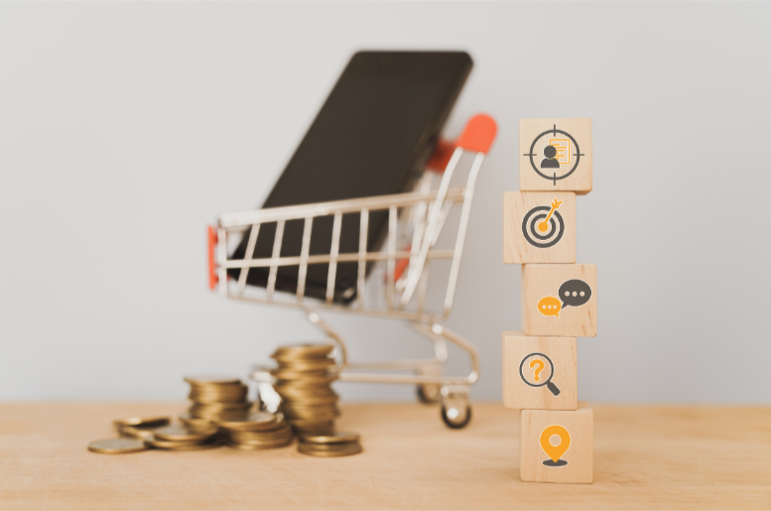

"Businesses that prioritize conscious consumerism and embed it into their CX strategy will gain a competitive advantage in the marketplace."
- Indra Nooyi, Former CEO of PepsiCo

Consider this: You want to purchase a new smartphone because your current phone starts malfunctioning, prompting you to seek a replacement. So, your customer behavior journey starts with problem recognition. The next stop of this journey is gaining information where you search for mobile phones online, comparing specifications, looking at reviews & checking out various models.
Your evaluation of alternatives involves weighing features like camera quality, battery life, & price, often influenced by recommendations from friends & family. After careful consideration, you make your purchase decision, choosing a model that offers the best balance of performance & affordability. Following the purchase, your post-purchase behavior includes evaluating the phone's performance & sharing her experience through social media & product reviews.
This process highlights the interplay of psychological factors (such as your need for a reliable device), social influences (advice from peers), & personal preferences, illustrating how consumer behavior encompasses the entire journey from recognizing a need to evaluating satisfaction after a purchase. Generation Z shoppers are twice as likely to make impulse purchases compared to those from the Silent Generation.

What is Consumer Behavior?
Consumer behavior refers to the study of how individuals, groups, or organizations select, purchase, use, & dispose of goods, services, ideas, or experiences to satisfy their needs & desires. It encompasses the decision-making processes & the actions taken in relation to buying & using products or services. Understanding consumer behavior involves exploring why people make purchasing decisions & how they use products or services. Some studies suggest that Gen-Z shoppers are twice as likely to make impulse purchases compared to those from the Silent Generation, which highlights the need to study consumer behavior.

Types of Consumer Behavior:
- Complex buying behavior
This behavior occurs when consumers make high involvement purchases that involve significant research & decision-making. The purchases are typically expensive, infrequent, & carry a higher risk.
Example: Buying a luxury car or a house. This requires initiative to spend time researching different models, comparing features, seeking expert opinions, & considering long-term implications before deciding as it is a once in a blue moon purchase.

- Dissonance Reducing Buying Behavior
This type of behavior happens when consumers are highly involved in a purchase but see little difference between the available options. The focus is on reducing post-purchase dissonance, or the feeling of uncertainty after the purchase.
Example: Purchasing a high-end washing machine where several brands offer similar features. Consumers might feel anxious about whether they made the right choice, so instead of facing regret they look for reassurance post-purchase.

- Habitual Buying Behavior
Habitual buying behavior involves low-involvement decisions where the consumer routinely buys the same product without much thought or evaluation of alternatives. Extensive Research does not have a place in this type of behavior.
Example: Regularly buying a specific brand of toothpaste. The consumer repeatedly chooses the same brand due to familiarity & convenience, without actively comparing other options.

- Variety- Seeking Buying Behavior
This behavior occurs when consumers make low-involvement purchases but seek variety to satisfy their curiosity or need for change. Despite the low cost, consumers are motivated to try new options.
Example: Choosing different flavors of snacks or trying various brands of cereal. The decision is influenced by a desire to try something new rather than necessity.

Elements influencing Consumer Behavior:
Psychological Factors
- Perception: How consumers view & interpret information about products or brands.
- Motivation: The internal drive or need that prompt purchasing behavior.
- Learning: How past experiences & information affect future buying decisions.
- Beliefs & Attitudes: Personal views & feelings toward products or brands that influence choices.

Personal Factors
- Age: How age & life stage affect needs & buying habits.
- Occupation: Job & career influence product preferences & purchases.
- Economic Situation: Financial status & income level determine spending ability.
- Lifestyle: Interests & activities shape product choices & brand preferences.

Social Factors
- Family: Family needs & preferences impact buying decisions.
- Reference Groups: Influence from friends, colleagues, & social networks.
- Social Status: Social class affects purchasing power & product selection.
- Cultural Norms: Shared cultural values & practices shape buying behavior.

Economic Factors
- Economic Conditions: General economic environment influences consumer spending.
- Price Sensitivity: Reactions to price changes impact purchasing decisions.

Situational Factors
- Purchase Situation: Context & circumstances of the purchase affect decisions.
- Temporal Effects: Time-related factors like seasons or sales are effective to influence buying behavior.
- Physical Environment: Store layout & ambiance impact the shopping experience.

Models to understand consumer behavior:
- Maslow's Hierarchy of Needs is a psychological theory proposing that human needs are arranged in a hierarchical order. People are motivated to fulfill these needs sequentially, starting from the most basic:

- Physiological Needs: Basic survival needs such as food, water, & shelter.
- Safety Needs: Protection from harm, financial security, & a stable environment.
- Social Needs: Belongingness, love, & relationships with others.
- Esteem Needs: Self-esteem, respect from others, & recognition.
- Self-Actualization: The pursuit of personal growth, creativity, & achieving one's full potential.
According to Maslow, higher-level needs become prominent only after lower-level needs are met.

- The Engel-Kollat-Blackwell (EKB) Model is a framework for understanding consumer decision-making. It breaks down the process into distinct stages:
- Problem Recognition: Identifying a need or problem that requires a solution.
- Information Search: Gathering information about potential solutions, including research & seeking advice.
- Evaluation of Alternatives: Comparing different products or options based on factors like features, quality, & price.
- Purchase Decision: Choosing the product or service that best meets the identified need.
- Post-Purchase Behavior: Reflecting on the purchase decision & its outcome, including satisfaction or dissatisfaction with the product.

The model highlights how consumers move through these stages & how various internal & external factors influence each stage of the decision-making process.

By understanding these elements & models, businesses can better anticipate consumer needs, create targeted marketing strategies, & improve their overall approach to engaging with customers.
StoryTelling is an approach to influence customer behavior by changing the way customers perceive & engage with a brand. Do you want to be a part of this revolution? Connect with experts at BlewMinds right away & influence your customer behavior.

Keywords: StoryTelling | Initiative | Effective | Regret | Consumer Behavior
Focus: Consumer Behavior
Meta Description: StoryTelling can influence customer behavior by changing the way customers perceive & engage with a brand. Learn how it happens.

